

|  |  |  |  |  |  |
| --- | --- | --- | --- | --- | --- |
| Team Name: | LLAMA Bell | | | | |
| Team members: | Pini Faran | Inna Trava | Arik De-Mayo | Assaf Avital | Amit Zvik |
| Country: | Israel | | Site: | Raanana North | |

# Overview

**Fighting fake news in real life video streams**

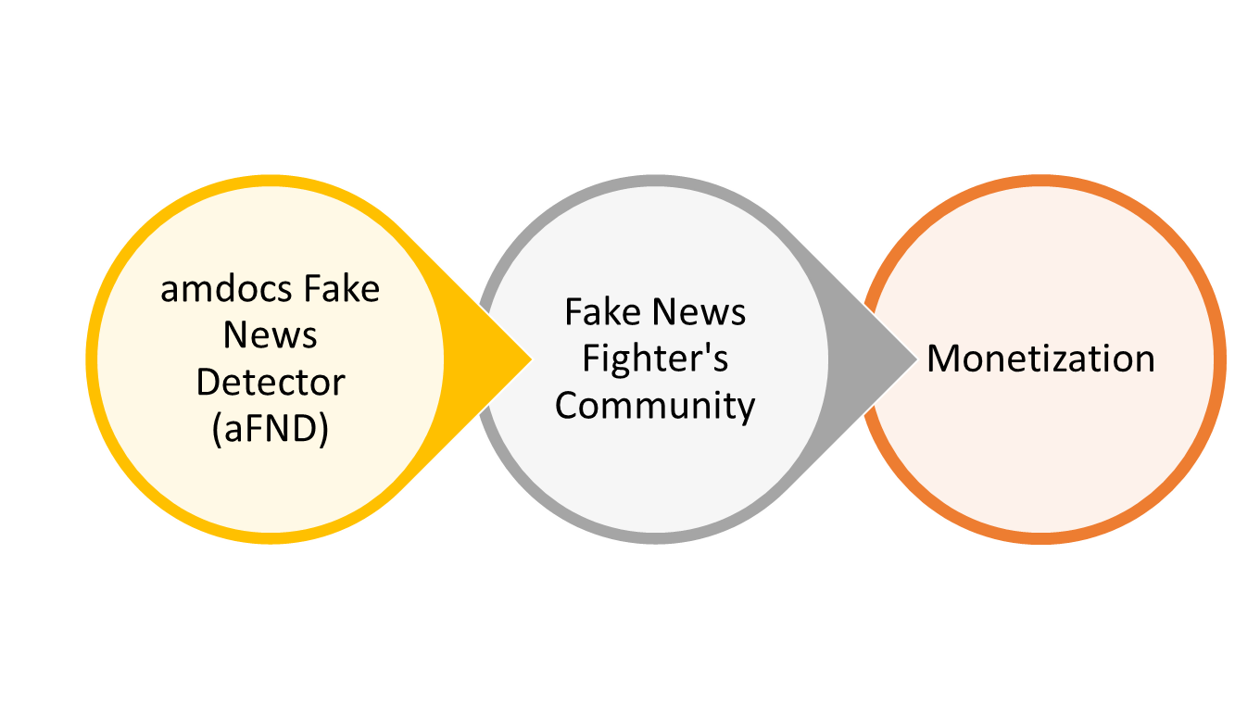Automatic detection of fake news in real life video streams using content analysis and machine learning. The detection result will be displayed on the playing device as well as published in a dedicated fake news fighter’s community in which users can confirm or reject fake news, manually report fake news and commute with other fake news fighters.

# Used Technologies

## Platform Used

|  |  |  |  |
| --- | --- | --- | --- |
| **Platform:** | **Vubiquity** | **Vindicia** | **UXP** |
| **Used in project?** | Y | Y | Y |
| **What was used?** | Verify transcription against legit media available on Vubiquity | Credit management for community users | User login across all devices and to the fake news fighters community |

# Description

Fake news has already caused death (in India) and impacted the results of the election is several countries (USA, UK and Israel). With today’s video editing application, anyone can easily generate fake news and publish them on social media as In Real Life video streams. Since Generation Z consumes media mainly through YouTube and Instagram, the risk of fake news becoming viral and impact people behavior is real more than ever.

Our solution consists of two main parts:

* Amdocs Fake News Detector (aFND), a mechanism for automatic detection of fake news in real life video streams
* Fake news fighter’s community, win credits for fighting fake news

Amdocs Fake News Detector (aFND) leverages edge computing technologies with web services and machine learning for automatic analysis of video streams. The automatic fake news detection is done using content analytics of the audio. Key steps: extract meaningful keywords from video streams and search for similar posts on the web. Analyze the web search results to determine fake vs legit news.

This tool leverage machine learning python libraries, Google search API and other technologies.

Fake news fighter’s community which allow Gen Z to get actively involved in fighting fake news in several means, for every activity they do the consumer will receive a credit. The more credits they gain the higher rank they get. Top ranked contributors will get public credibility rank that can be used all over the web.

Gen Z can gain credits by running the Amdocs Fake News Detector (aFND) on devices while watching real life streams, by manually reporting on fake news in the fake news fighter’s community and by providing feedback on the automatic Fake News Detector. The feedback will be also used for further training of the machine leaning algorithms for improving the accuracy of future detections.

